**CSE 370 – Database Systems**

## **Theory Section 05 / 06 | Assignment 02**

## **Spring 2023**

**Full Name (in Block Letter): __________________________________ ID: _____________________**

**Question 1 [CO1] : 20 Points**

Suppose that each of the following update operations (a-j) is applied directly to the database state shown in Figure A2_1. Discuss all integrity constraints violated by each operation (check Figure A2_2 for Referential Integrity constraints on the database of Figure A2_1). If any, provide different ways of enforcing these constraints.

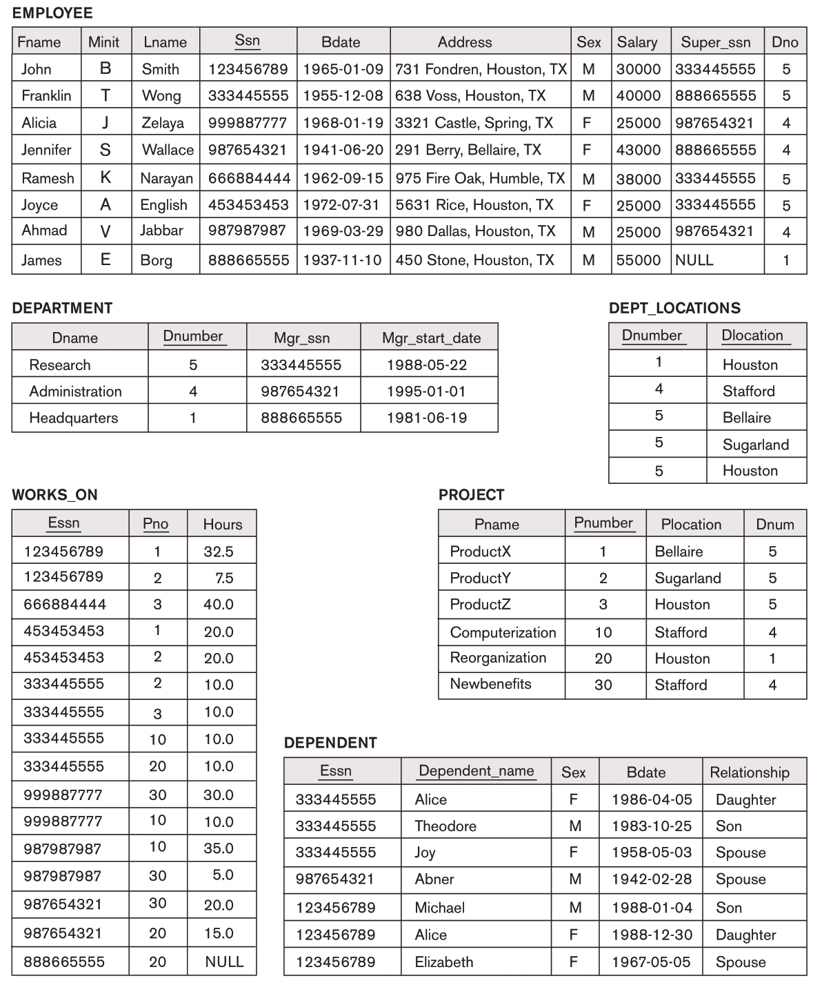

Figure A2_1 : COMPANY database.

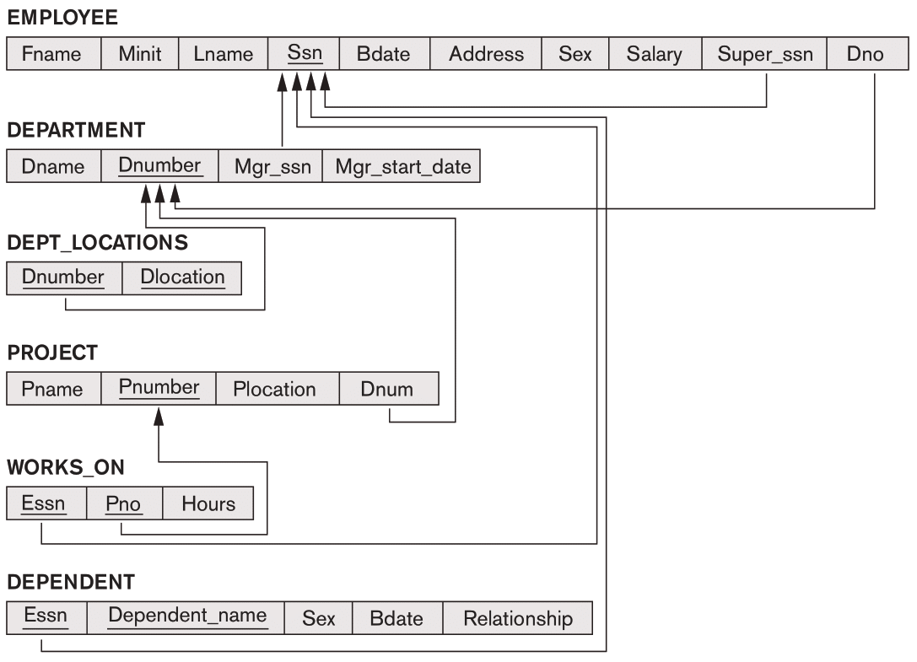

Figure A2_2 : Referential integrity constraints on the COMPANY database of Figure A2_1.

**Consider each of the following operations (a-j) independent of each other. Each operation will be applied directly to the database state shown in Figure A2_1. For example, when you will consider no. b, you should not consider whether no. a has successfully been completed.**

|  |
| --- |
| **a.** Insert <'Gavin', 'F', 'Harrison', '943775543', '1972-06-21', '2365 Newcastle Rd, Bellaire, TX', 'M', 58000, '888665555', 1> into EMPLOYEE.  **Answer:** |
| **b.** Insert <'ProductA', 4, 'Bellaire', 2> into PROJECT.  **Answer: referential integrity** |
| **c.** Insert <'Production', 4, '943775543', '2007-10-01'> into DEPARTMENT.  **Answer: key cons** |
| **d.** Insert <'677678989', NULL, '40.0'> into WORKS_ON.  **Answer:**  **Referencial, entity integrity** |
| **e.** Insert <'453453453', 'John', 'M', '1990-12-12', 'Spouse'> into DEPENDENT.  **Answer:**  ok |
| **f.** Delete the WORKS_ON tuples with Essn = '333445555'.  **Answer:**  ok |
| **g.** Delete the EMPLOYEE tuple with Ssn = '987654321'.  **Answer:**  **referencial** |
| **h.** Delete the PROJECT tuple with Pname = 'ProductX'.  **Answer:**  **ref** |
| **i.** Modify the Mgr_ssn and Mgr_start_date of the DEPARTMENT tuple with Dnumber = 5 to '123456789' and '2007-10-01', respectively.  **Answer:**  **ok** |
| **j.** Modify the Super_ssn attribute of the EMPLOYEE tuple with Ssn = '999887777' to '943775543'.  **Answer:**  **ref** |